MULTIMEDIA PROJECT REPORT

Deadline: Friday April 25th 2014 5pm

PROJECT TEAM
Student No | First Name | Surname
X13112406 | Navjot Singh | Virk
X13114531 | Soffyan | Ali

Navjot Multiplication Tables
(Khalsa Productions Dublin )

- OVERVIEW

Motivation for the Project

Project Idea
We have come up with an innovative idea of marketing a Mobile App (that works on Android platform and is developed by - Navjot) and Making a responsive website for this mobile app and an interactive animation to illustrate how this app works and helps you with daily life. We are also going to use YouTube to market this app and will have Facebook and twitter pages for the app/website, and QR codes. So, that we can cover large number of audiences.

Why this Idea?
When we were planning for the project I told Soffyan about the app and then we come up with the idea of promoting and selling our own product instead of someone else and the advantage of using this idea was that we know everything about the app and is our own work. We can make an interactive animation illustrating how this app works and we can also use the screenshots of the app in our websites gallery and we don’t have to worry about Copyright. As this app really exists and is on Google App store further this animation can be used to sell the app on play store.

Marketing Strategy
We have planned our marketing strategy that we are going to have a Website and use Fireworks for Logo and other graphical components, an Animation in Flash, YouTube video and Facebook/twitter pages.

Wireframes
screenshots are below –

STORYBOARD / WIREFRAME

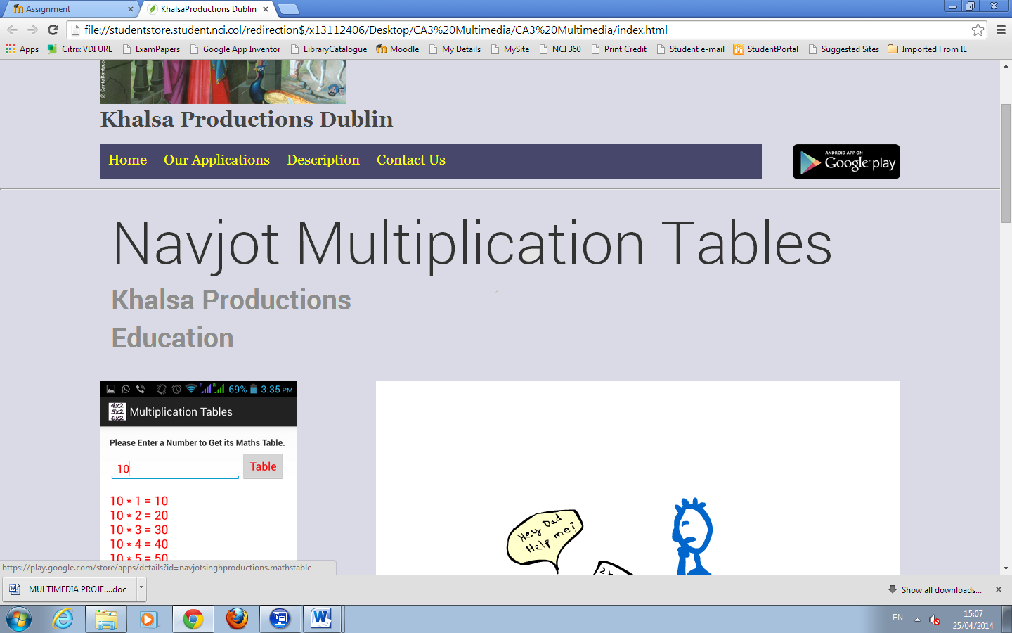

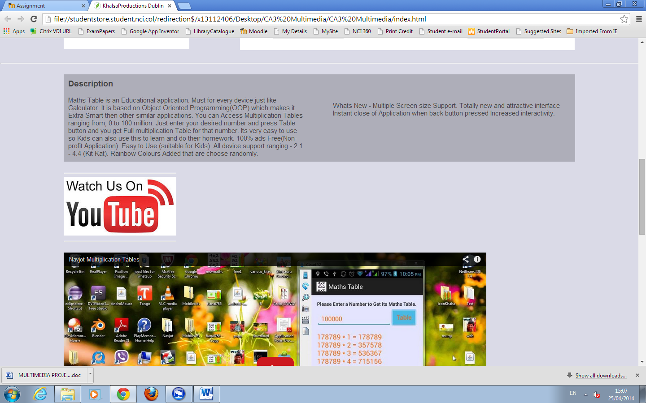
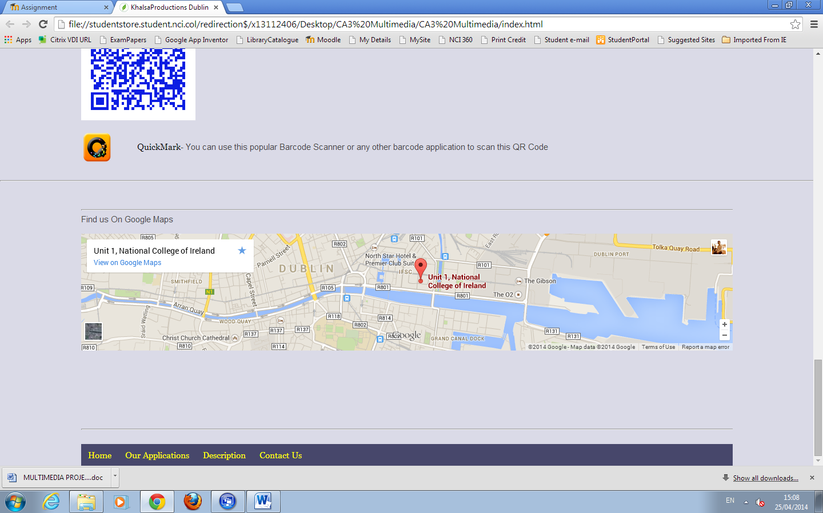

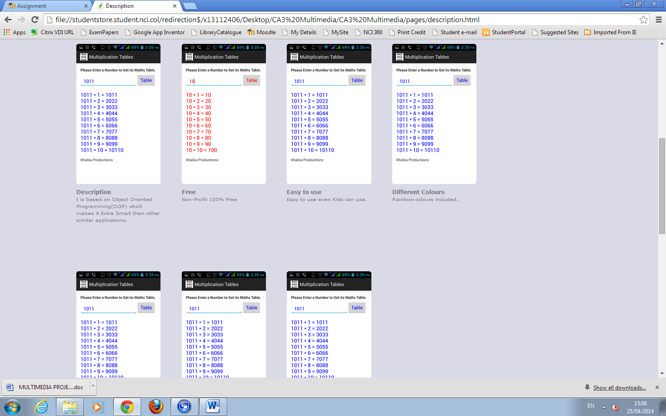

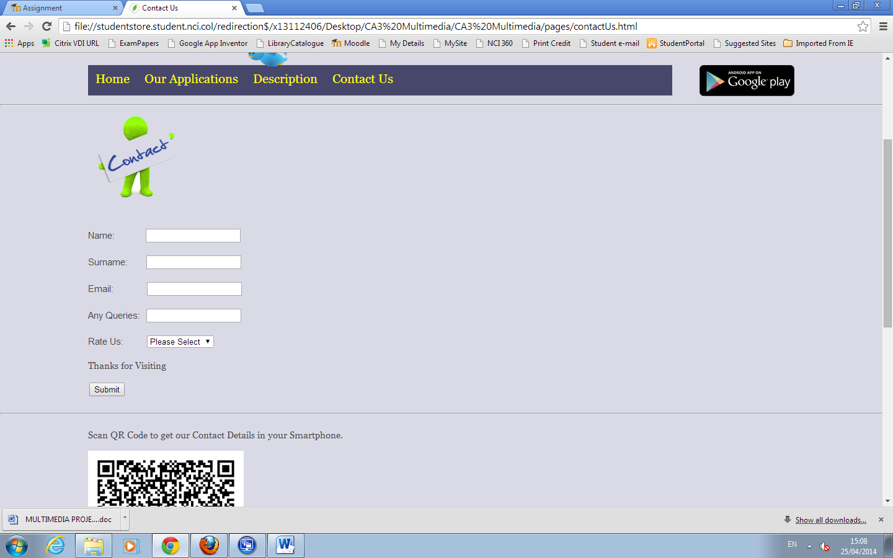

- RESEARCH

Our project Idea is to promote our own android application – Navjot Multiplication Tables using Responsive Website, Facebook and Twitter and Interactive animation.
There are very few applications available in market similar to our application. As our application provides Multiplication tables in just 2 simple steps that are Enter number and click table button whereas other applications have hard to understand interface, more steps, limited number of tables, ADS and complex navigation. But our application stand alone in market which provides unlimited number of Tables ranging from 0 to 10 million, 100% Ads Free, multiple screen size support and good interface, easy to navigate and takes less space on RAM.
So, our idea is totally different from other application that’s why we think it will improve on the current products on the market. Our product is based on Object Oriented Programming (OOP) which makes it Extra Smart then other similar applications. It is very easy to use so Kids can also use this to learn and do their homework.
All Android device support ranging - 2.1 - 4.4 (Kit Kat).
Rainbow Colours Added that are choose randomly.

- PRODUCTION LOG
Our project concept is to promote our own android application – Navjot Multiplication Tables using Responsive Website, Facebook and Twitter and Interactive animation.
We have created a fully responsive website using CSS and using 1120 grid system our website has YouTube video and google maps are fully responsive and a responsive gallery and interactive animation.
We faced some problem during development are as follows -
When we were working on citrix in Adobe professional and were nearly done adobe closed unexpectedly and then we were not able to open the .fla file.So, we informed IT support and they could not solve that and they said they might be able to recover that file from college backup but that might take some time. So, we have our SWF file working but not fla . But we tried to decompile the swf file and we have added that folder to the submission that contains a working fla file but its slightly different from the original file.
Adobe Fireworks Elements

We used Fireworks to remove background, resize and scale some of the images used on our website, edit images to use in our animation.
Adobe Flash Elements
We used Flash to make interactive animation to describe the functioning of our product. Overall adobe flash professionals experience was not that great as it stopped unexpectedly.
Online / Social Media Elements

This is the link to application - https://play.google.com/store/apps/details?id=navjotsinghproductions.mathstable
Facebook Page - https://www.facebook.com/pages/Khalsa-Production-Dublin/637946022942609
Twitters Page - https://twitter.com/KhalsaDublin

Responsive Website Elements

Our website is fully responsive from head to toe. Which include responsive images, Qr code, text, gallery, gallery text, youtube video and google maps.

Other Digital Elements

Google PlayStore - https://play.google.com/store/apps/details?id=navjotsinghproductions.mathstable

- PROJECT TEAM

The project team breakdown was as follows –
I (Navjot) did Website, Project proposal, twitter page and report and the Navjot Multiplications Tables application also belong to me.
Soffyan did Animation and facebook page and helped me in writing report.
Yes, we worked well as a group and had good communication over phone and facebook and sitting together and working.

- CONCLUSION
After completion we feel really relaxed and cool. As a group we think we have nearly accompineshed our goals that we set if we had more time we would have made a more interactive animation

- REFERENCES

Css-tricks.com, (2014). [online] Available at: http://css-tricks.com/seamless-responsive-photo-grid/ [Accessed 21 Apr. 2014].
Helpx.adobe.com, (2014). Animation software tutorial | How to animate cartoons & drawings. [online] Available at: https://helpx.adobe.com/creative-cloud/learn/start/flash.html [Accessed 17 Apr. 2014].
Johnson, J. (2014). How to Build a Responsive Thumbnail Gallery | Design Shack. [online] Designshack.net. Available at: http://designshack.net/articles/css/how-to-build-a-responsive-thumbnail-gallery/ [Accessed 19 Apr. 2014].
Rowinski, D. (2014). 10 Developer Tips To Build A Responsive Website [Infographic]. [online] ReadWrite. Available at: http://readwrite.com/2013/04/16/10-developer-tips-to-build-a-responsive-website-infographic#awesm=~oCsnsYxuqfrqJB [Accessed 22 Apr. 2014].
Uehara, R. and Uehara, R. (2012). How to Create a Responsive Website in about 15 Minutes. [online] 1stwebdesigner.com. Available at: http://www.1stwebdesigner.com/css/responsive-website-tutorial/ [Accessed 22 Apr. 2014].
YouTube, (2014). Adobe Flash CS3:How to create a Simple Animation. [online] Available at: http://www.youtube.com/watch?v=rbeObl5UsJ4 [Accessed 25 Apr. 2014].

